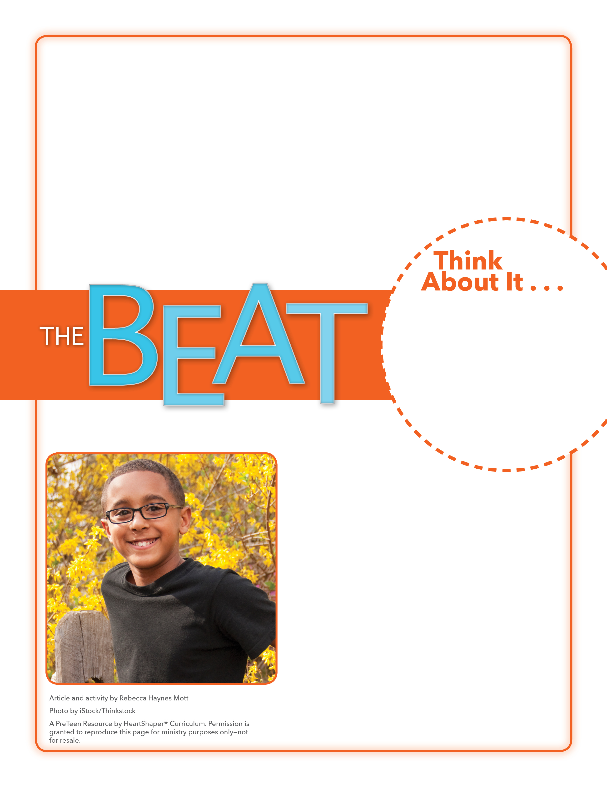
• What different choices could the teens have made before and after taking the bike?
• How might the owners have responded differently to the teens’ request for forgiveness? Would the
owners have felt the
same happiness?

Forgiveness Draw

Remember, you can go to God in prayer whenever you need His forgiveness.

Have the kids take turns drawing pictures on the board that show actions other kids their age might do to them that would need forgiveness. The rest of the students can guess the situations being drawn. (Example: stick figure of a person making fun of you) After several situations have been guessed, take a vote and circle the action that might be the easiest for students to forgive. Play a second round, drawing pictures that show actions the students might do to others that would prompt the need for forgiveness. (Example: You trip a person on purpose.) After the situations have been guessed, vote and circle the action that might be hardest for another person to forgive. SAY: Let’s look at a story Jesus told to better understand that God is a forgiving God.
is a forgiving God.e can reflect well on God.

October 22, 2017
Lesson 8
This past summer, shortly after Mel Flesher’s friend bought an old dirt bike and fixed it up so his kids could learn to ride, two teenagers broke the lock and stole the bike. But then seeing pictures of the kids who owned the bike riding it, and reading what Mel had posted online about the bike being stolen, made the teens regret what they had done. They wanted to make the situation right. About a week later, as Ms. Flesher was leaving for breakfast, she discovered the bike was back in its place—with a new lock, keys, full tank of gas, and the oil topped off. She also found a note from the teens that said they were sorry for stealing the bike; they hoped the family could forgive them. Ms. Flesher happily updated her previous online post, saying, “It’s a good morning!☺☺☺☺☺” She wrote to the teens, “Thank you for doing the right thing!!! . . . We forgive you and hope this taught
you a lesson.”

