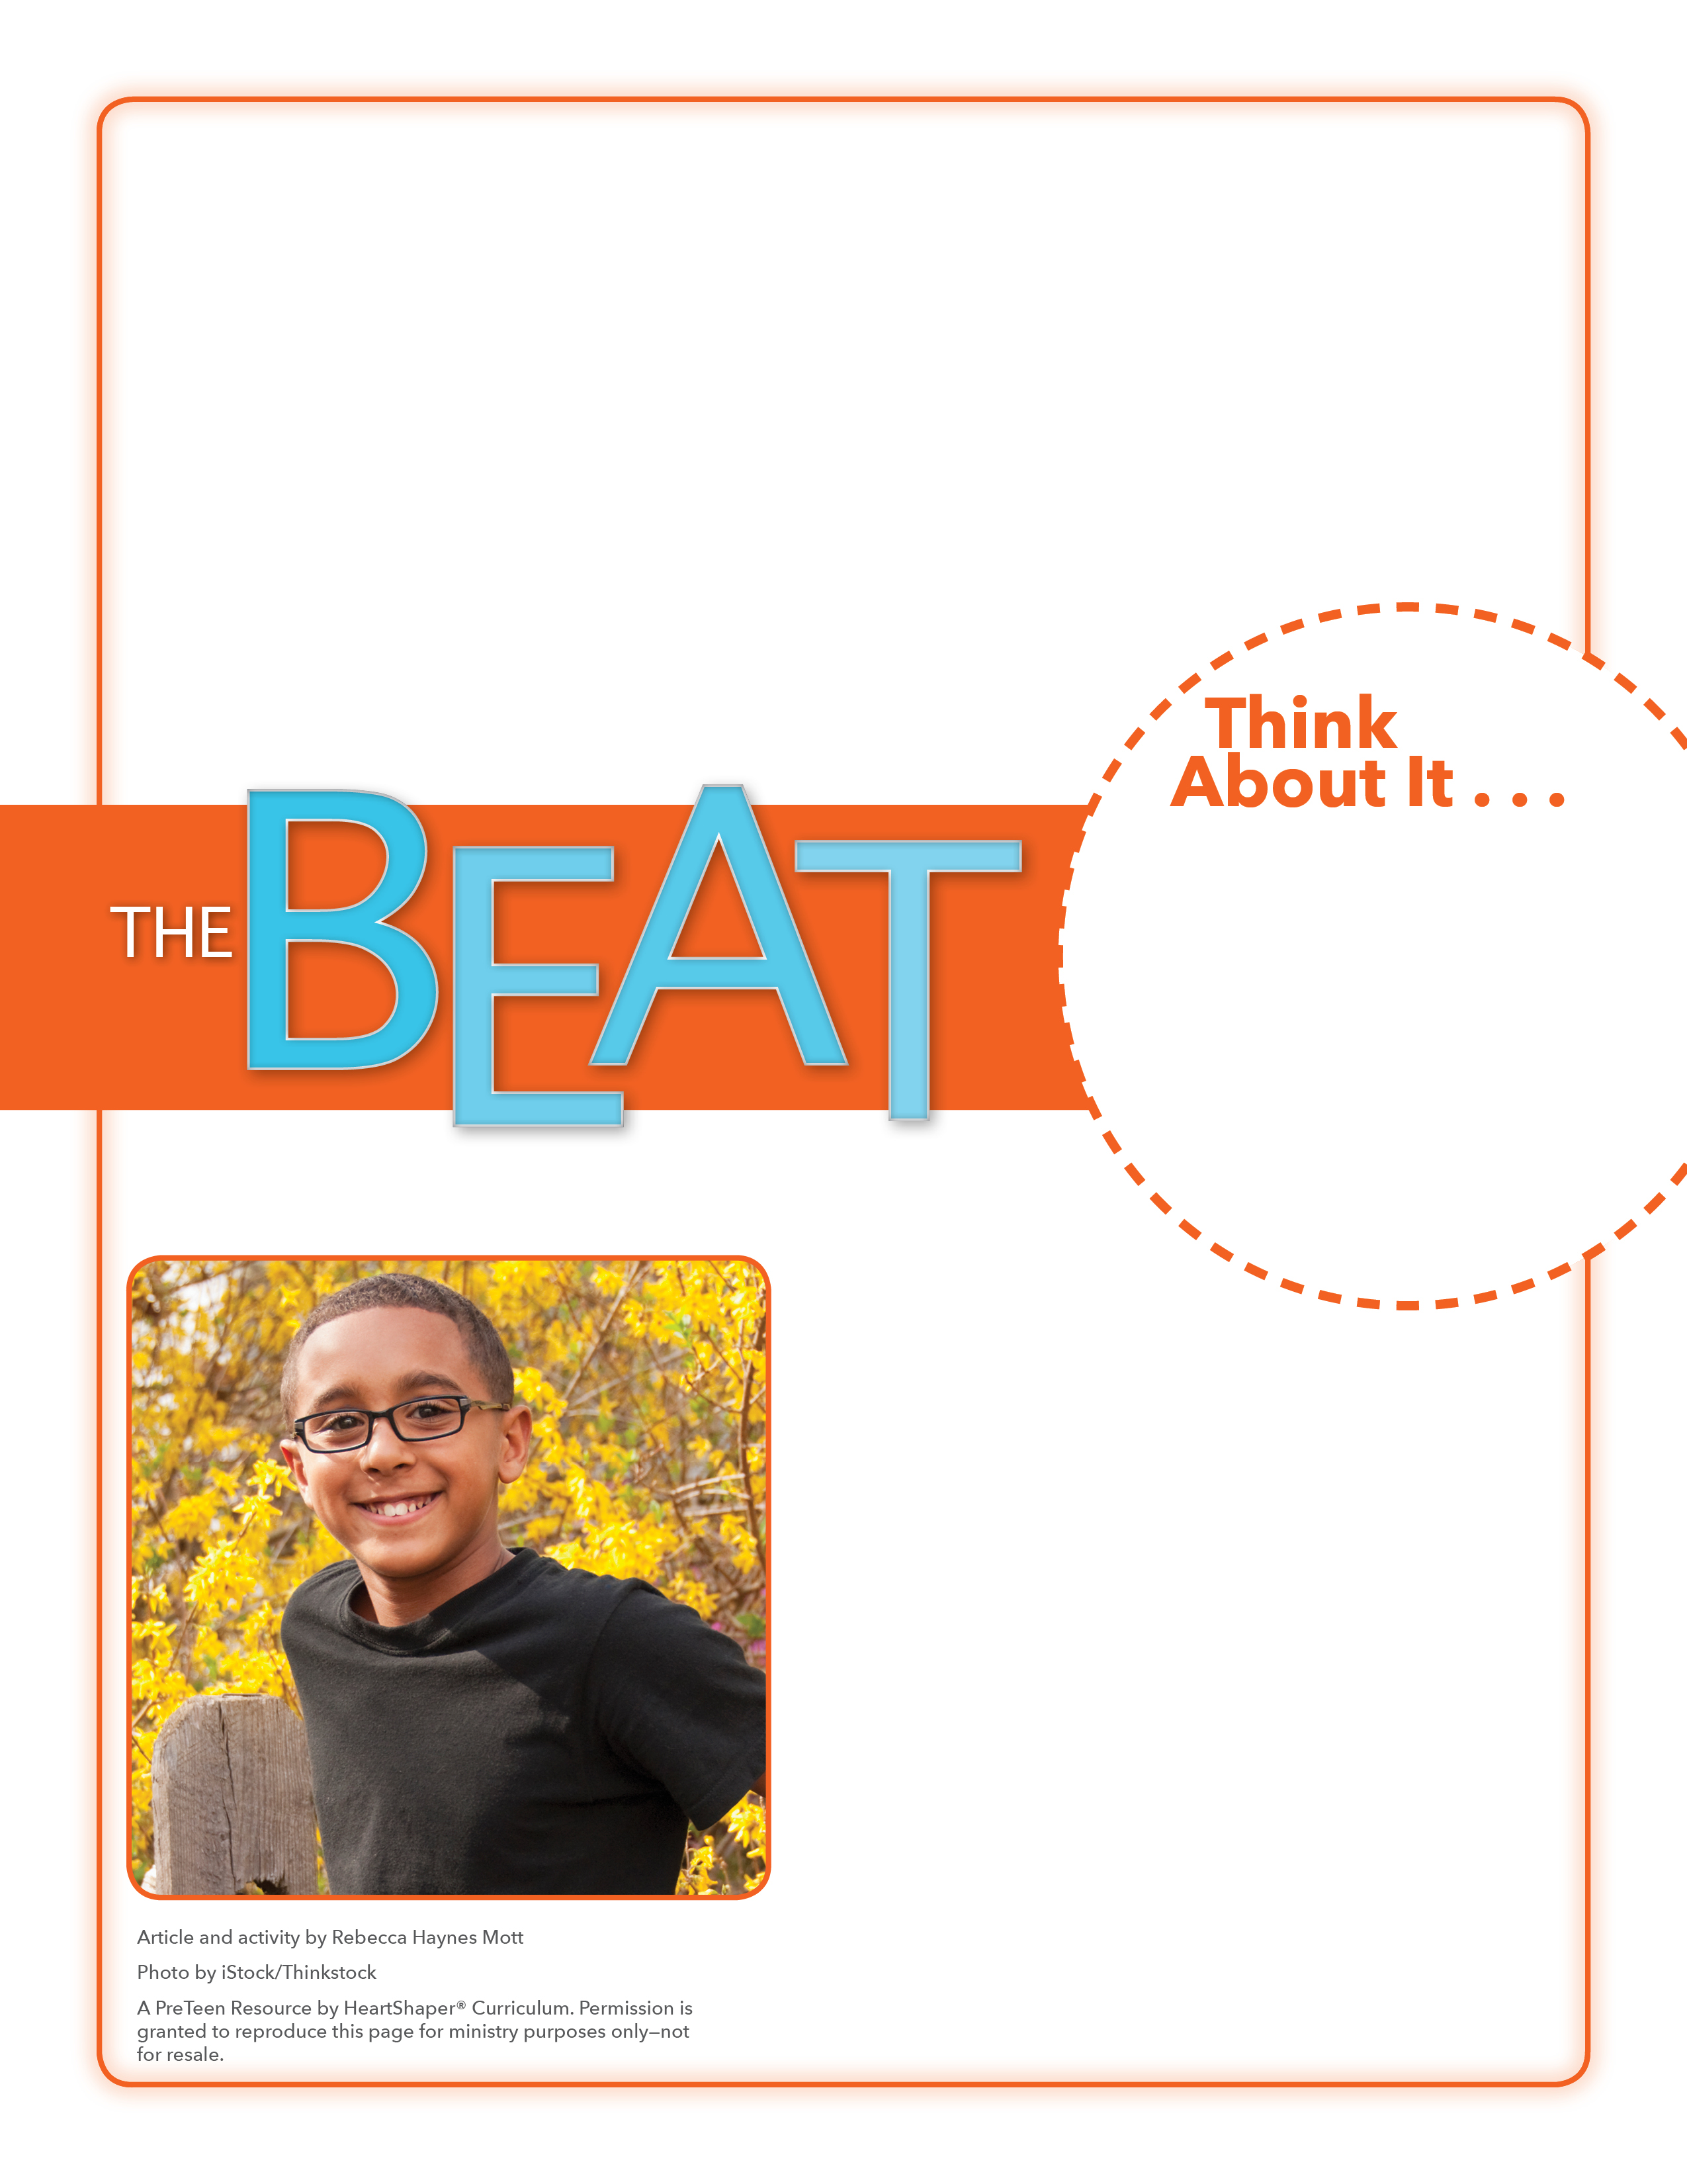
• What are some ways people might be different from others?
• How could it feel to be the only “different” one in a group?

HAND TO HAND
What can we do together to use our abilities and talents to serve God and others?

Have the students trace their hands onto sheets of paper and then switch the papers with other classmates. Classmates should write on other students’ traced hands things that make those people special and unique. Take turns holding up and sharing the finished hands with other classmates. If time allows, cut out the hands and attach them together in a circle to make a classroom wreath. SAY: God wants us to accept people’s differences. Let’s see what the Bible says about that.

September 24, 2017
Lesson 4
All 7.5 billion people on earth today came from the same first couple, Adam and Eve, but there are millions of differences among us. Today’s people speak between 5,000 and 6,000 different languages. The people are classified by races, such as Hispanic, Black, Asian, and Caucasian. Citizens of the world’s nearly 196 countries live in different environments and have different traditions. They enjoy different kinds of food, clothing styles, and leisure activities. Even people who live in the same area and who share the same race, language, and customs have differences in personalities, skills, and interests.
Sometimes it can be easy to exclude people who don’t fit in. In Sarasota, Florida, kids worked on a project called Uniquely United to show others that even though we are all different, we can come together and celebrate our uniqueness. The kids traced their hands onto paper, decorated the hands to represent themselves, and then cut out the hands and joined them together in a circle to represent how combining differences can
create something beautiful.

