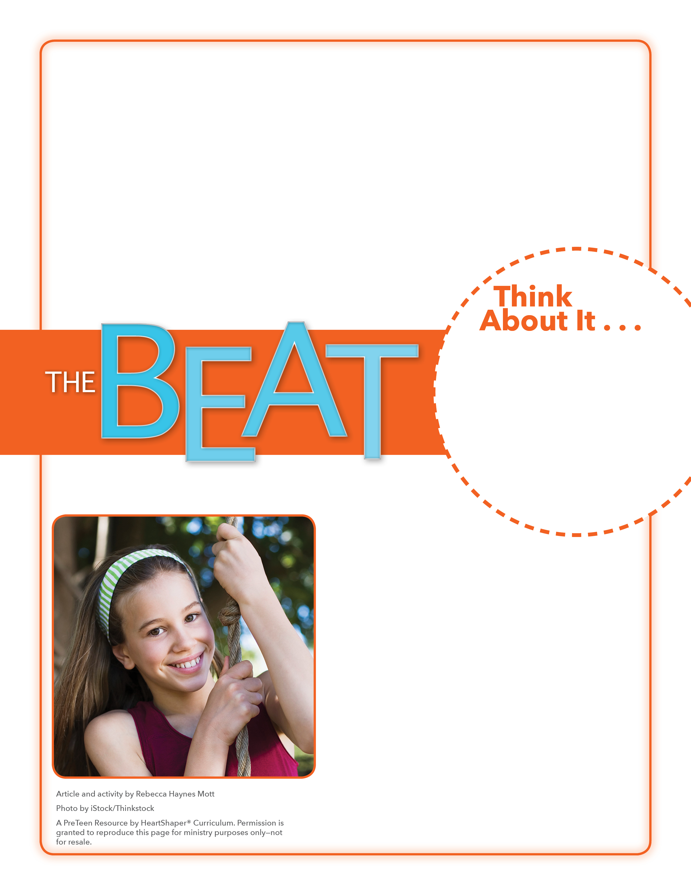
• How hard do you think it was for Lorelai to develop her abilities?

• What are some abilities you have?

Gifts from God
Will you commit your abilities to God for His use?
On the board, draw a large square with a ribbon on top to represent a gift box. Have preteens pair up. Tell them to talk with each other about the abilities they have and are developing. SAY: Your abilities might even be a surprise to others, somewhat like Lorelai’s surprising ability to play the piano with her feet. When preteens are done discussing, tell them to each write in the box at least one ability they have. Quickly read aloud what’s written in the box. The abilities we have are gifts from God! Let’s dig into God’s Word and find out about someone who thought that he didn’t have any special abilities that God could use.

August 13, 2017
Lesson 11

When Lorelai Mosnegutu’s mother saw that her baby girl had been born without arms, she abandoned her. When Mama Vio, a social worker in the same Romanian neighborhood, saw that Lorelai needed a family, she adopted her. Even though everyone pitied Lorelai and assumed she would only become a burden, Mama Vio knew the helpless baby had special abilities just waiting to be discovered, and she taught Lorelai to work hard to develop them. In January, Lorelai, who is now 14 years old, stunned the world when she shared those abilities on the TV show Romania’s Got Talent. The hushed audience was brought to tears when they heard Lorelai singing and playing the piano with her feet. Lorelai’s determination to develop and share her abilities was inspiring and humbling. She won the competition and the video of her performance went viral.

