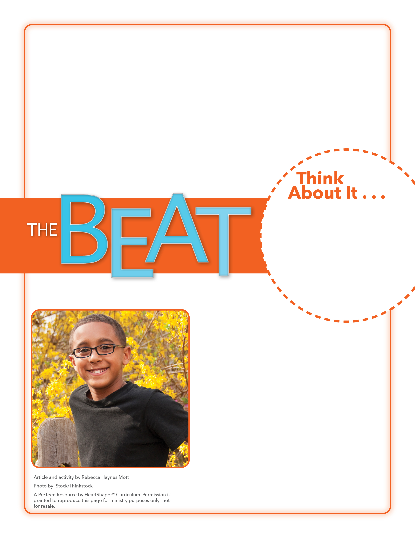
• Who has been impacted by Mandi’s desire to do good for others?
• Name some other organizations and people who do good for others?

Looking Back
How will you thank God by doing good this week?

Have students close their eyes and take a “memory walk” through the last couple of days, picturing what they have experienced and seen. Tell them to recall things that relate to doing good for others: needs they may have noticed, groups who were working to do good, or opportunities they had to help. After a couple of minutes, have the students open their eyes and share their observations. Write on the board some of the things kids remember experiencing and seeing. SAY: Let’s dig into God’s Word and learn about a woman who did good for others.

November 26, 2017
Lesson 13
Mandi Simon has been interested in helping others for a long time. When she was 7 years old, Mandi held a car wash to raise money for kids in need. But Mandi wanted to do more. Her excitement and passion for doing good was contagious; and when others began to join in her projects, Mandi’s mom helped her set up a nonprofit organization. Since her last name is Simon, Mandi named the organization Simon Says Give. The group began to raise funds, with a focus on helping parents with financial needs to throw birthday parties and provide gifts for their kids. The group also collects school supplies to give away each fall. This past fall, Simon Says Give celebrated its fifth anniversary. Since it began in 2012, the organization has spread to other locations and impacted more than 125,000 kids. Simon Says Give has thrown more than 500 birthday parties.
.

