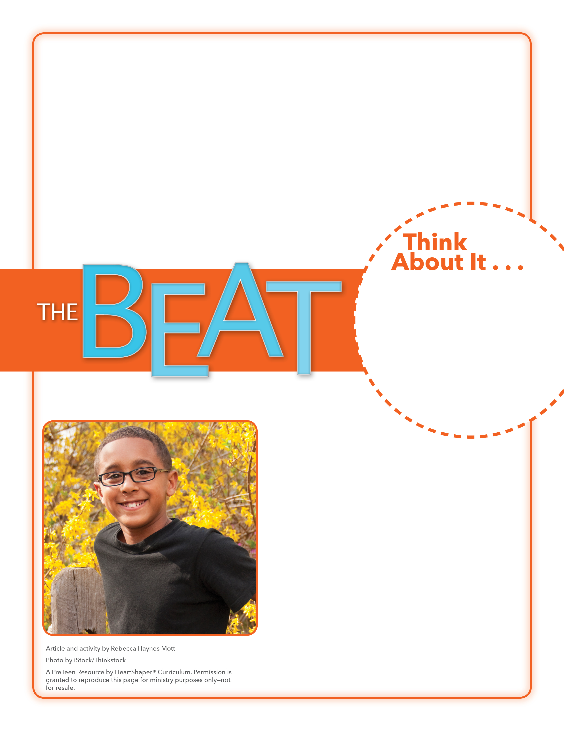
• What’s the first thing you would do if you were stranded on a desert island?
• How important is it for humans to have their basic needs fulfilled?

Basic Needs Brainstorm
What will you do this week to thank God for the many ways in which He meets your needs?

Quickly sketch on the board a simple coconut tree (a tall, skinny trunk with long, skinny leaves branching out on top). Ask the students to think about basic needs humans have. Ask the students to take turns coming to the board and drawing oval “coconuts” on the tree. They can write a basic need inside each coconut. Talk about how some of our basic needs are not as visible as food, clothing, and shelter. See whether the students can come up with some of our unseen needs. (Examples: safety and security, love, friendship, family, God) Have the students write these on the trunk of the tree.
SAY: Let’s dig into God’s Word and see what it says about our needs and who meets them.

November 19, 2017
Lesson 12
If you’re ever stranded on a desert island, don’t panic. In the movie Moana, Chief Tui, Moana’s father, tells her that their island gives them all they need. To make his point, Tui tells Moana to consider the coconut tree and how it provides for the people. The coconut tree, Tui sings, gives them fiber for nets, water that’s sweet, leaves to build fires, meat to eat. Moana is a fictional Disney story, but real directions for surviving on a desert island are very similar. The directions stress the urgency of finding sources for basic needs. One survival guide reinforces Moana’s dad’s assurance. The guide says that if an island has coconut palms, the survivor is in luck because every part of a coconut palm is useful for survival. In addition to suggesting eating coconuts, however, the guide also recommends eating bugs. Bugs are easy to find on most islands—and a great source of protein!

