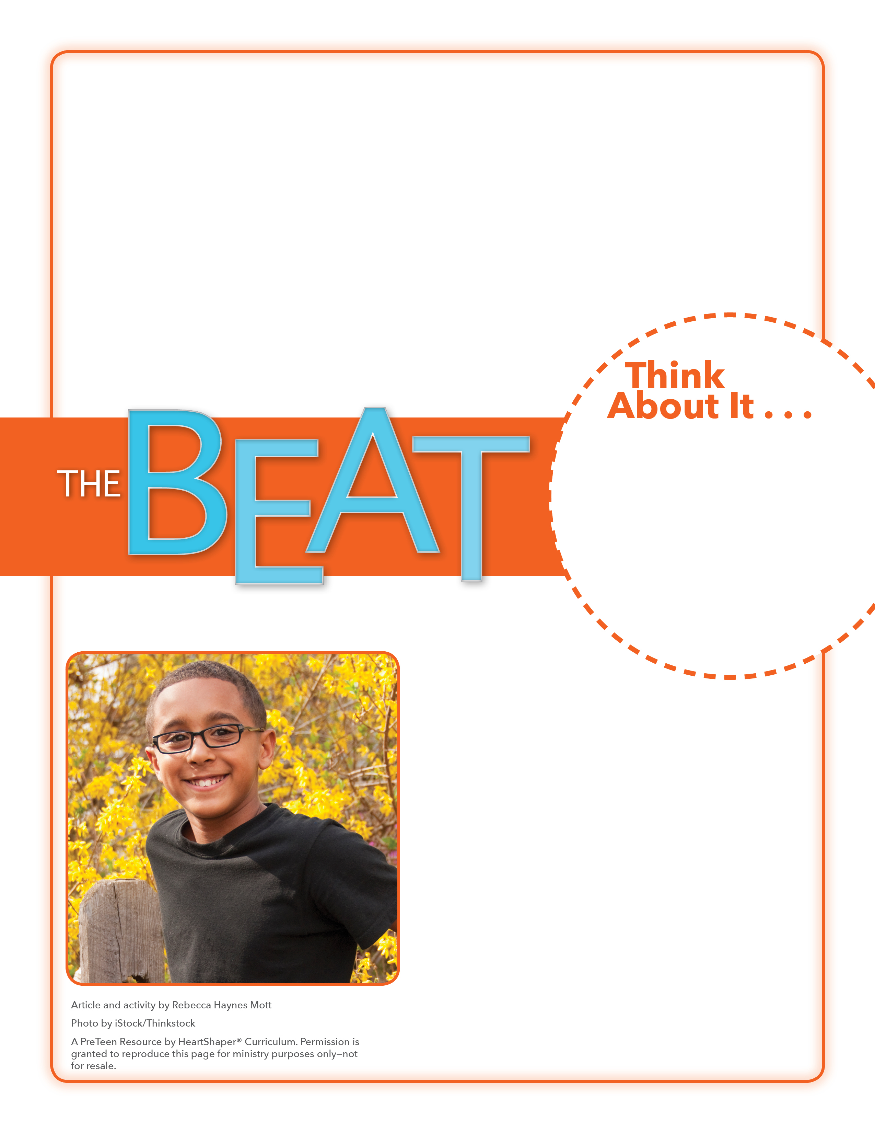
• Why did Elizabeth want to show gratitude and honor to her parents?
• How did Elizabeth show her parents that she appreciates what they do?

Why and What
Thank-Yous
What has God done for you recently that deserves your thanks? What will you say or do to thank God?

Provide paper and pencils. Have students break into pairs. Partners should list four to six people whom they have thanked for something. The partners can jot down why each person deserved their thanks and what was done to thank the person. Then have partners take turns sharing with the rest of the class one of the situations that deserved and resulted in thanks. SAY: Saying thanks should be a big part of how we get along and live with others. Let’s see what God’s Word says about why God is worthy of our thanks.

November 12, 2017
Lesson 11
In 2006, Katy and Juan Pena sold everything they had, left their home in Guatemala, and moved to the United States so Juan could go to a design school. They had tough times along the way, but didn’t give up on making a better life for their family. Their kids, Elizabeth and Joseph, watched Katy and Juan work hard for them, persevering through the years. Elizabeth, who is now 10 years old, wanted to find a special way to thank her parents for their example, determination, faith, and sacrifices. This fall she surprised them with a display that she had created for them. Her parents were overcome with emotion when they saw the display, which included hand-drawn family pictures, festive hats, and decorations. Juan’s favorite part of the display was a “diploma” that Elizabeth made to symbolize her future graduation from veterinary school. This is another dream that her parents will work to make come true.

