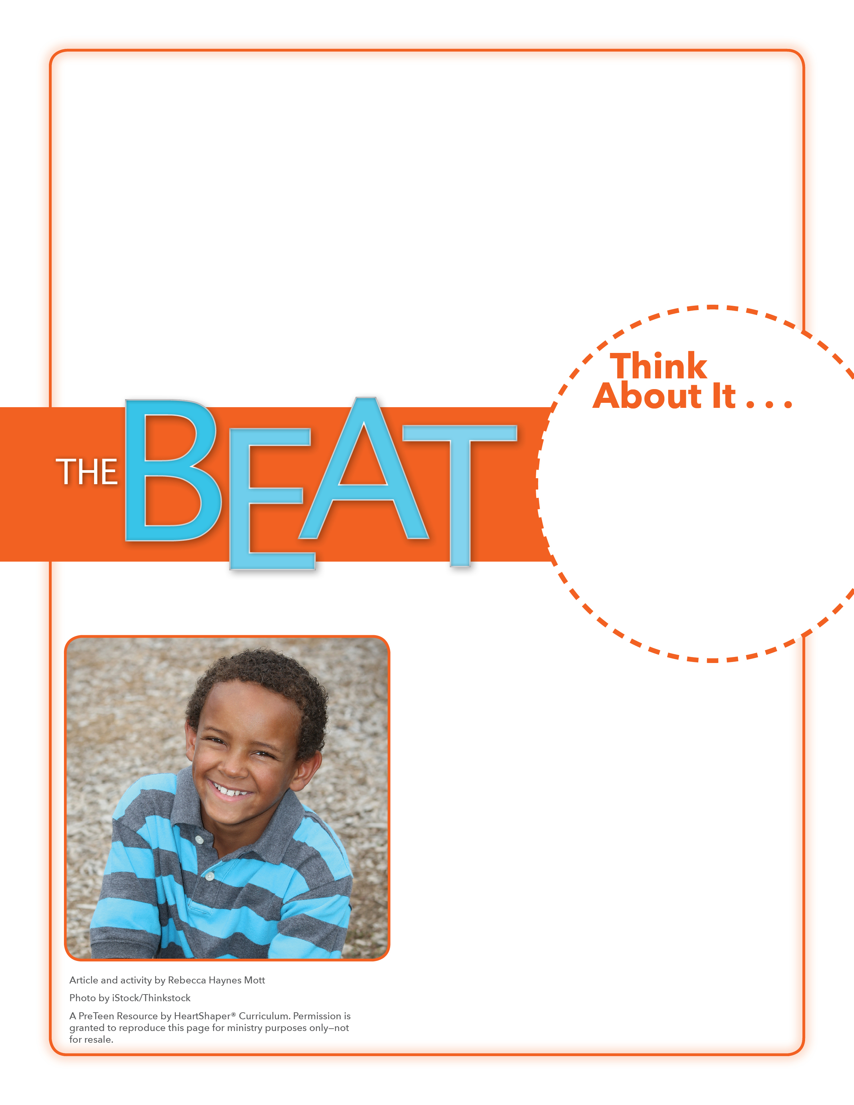
• How can words break you down?
• Why is it sometimes hard to choose to “speak life”?

Jailed!
In what situation do you plan to control your tongue this week?
On the board, draw a large square with vertical lines, representing a jail cell. Talk about how words that are not controlled can make us feel like prisoners or criminals. Put students into pairs and tell them to think of things they have spoken to others (or had spoken to them) that showed a lack of tongue control and had a bad effect. Write the phrases between the bars. SAY: Let’s dig into God’s Word to see what it says about the power of our tongues.

May 20, 2018
Lesson 12
What can build you up or break you down, make you feel like a prisoner or a king? The answer is: words. And “Words” is the title of a hit song by the Christian band Hawk Nelson. When asked how the song came about, Jonathan Steingard, Hawk Nelson’s lead singer, said that when he was at a difficult crossroads in his life, a band member from Mercy Me pulled him aside and spoke encouraging words to him for approximately an hour. When Jonathan realized the power that those words had in his life, he worked with his producer and a member of the band Sanctus Real to write “Words.” The song’s message is a reminder of how easy it is to forget the impact our words can have on others. Jonathan says the song’s chorus is a prayer, asking God to help us make our words speak life and truth. “Words” was released in 2013, but Hawk Nelson is still speaking life today. In April 2018, the band released its eighth album, Miracles. The band will be touring and
performing concerts around the United States this summer.

