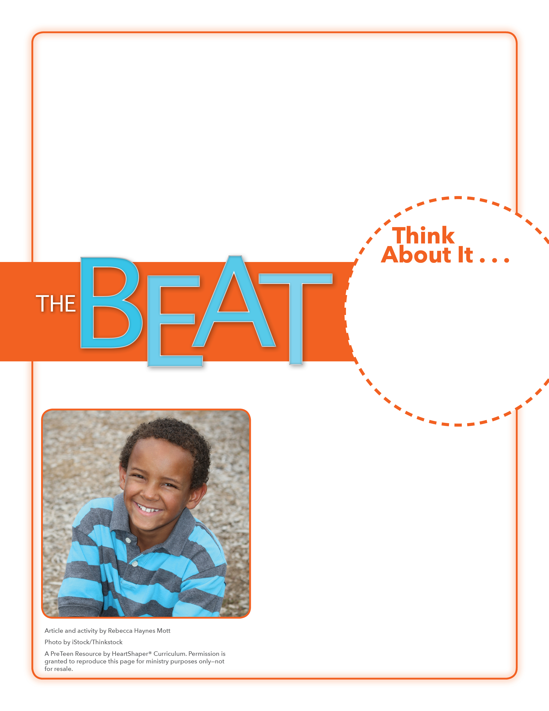
• What does it mean to show humility?
• Why might people call Malala’s humility “breathtaking”?

Pride or Humility?
What tempts you to be prideful? How can you plan to show humility in this area of your life?
Have students brainstorm categories that they or people they know could take pride in. (Examples: grades, sports, awards, possessions, looks) List these on the board. Ask students to find partners. Provide paper and pencils. Each pair should pick one category and jot down both a prideful response and a humble response a person might have if excelling in that category. Have each pair read (or act out) their responses aloud and see if the rest of the class can identify which response is humble and which is prideful. SAY: Let’s dig into God’s Word and see what Jesus teaches about showing humility.

May 6, 2018
Lesson 10
Some people call Malala Yousefzai a “humility hero.” When Malala was 11 years old, she started publishing a blog about how enemies were denying education to girls in her country. When soldiers shot her to shut her up, Malala survived, but she had to leave her country to be safe. That didn’t slow down Malala from speaking out. In 2014, it was announced that she had become the youngest person ever to win the Nobel Peace Prize. People around the world were amazed at Malala’s humility—she was totally uninterested in the fame! Malala wouldn’t even talk to reporters until she had finished her day in the classroom. On March 29, 2018, Malala got to go home to Pakistan for the first time since she was shot. She cried when her people said she was their hero. Others say that in today’s world of selfies, celebrities, and selfishness, Malala provides a breathtaking example of courage and humility.

