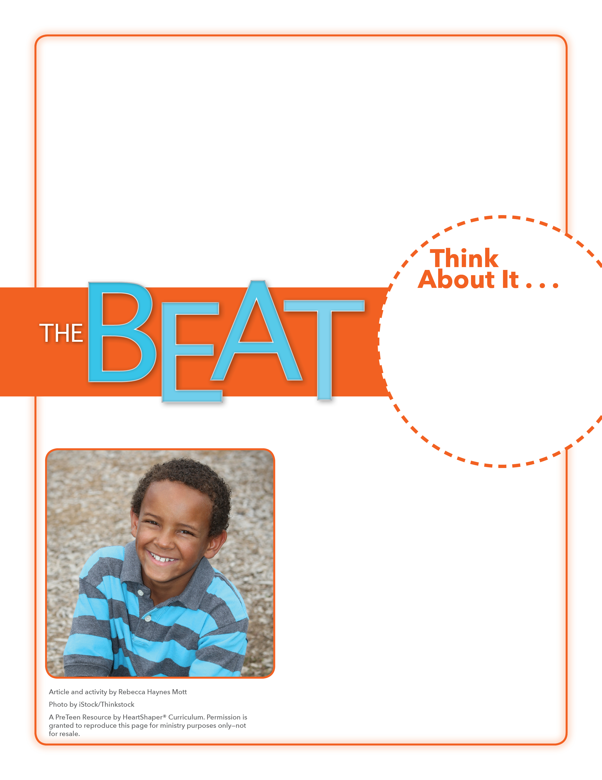
• Why do you think childhood years are divided into different stages?
• What is unconditional love? Why is it important in a parent-child relationship?

Being a Kid
What can you do this week to grow in your knowledge of God’s Word and His plan for salvation?
On the board, write “Important Parts of Being a Kid.” Under the title, list these points: 1. Being born and starting to grow; 2. Making mistakes and learning from them; 3. Following the lead of parents and caregivers.
Divide the class into three groups. Distribute paper and pencils and assign one of the points to each group. Group members should discuss and write down specific ideas or examples that show why their point is important in a kid’s life. Have groups share their observations with the class. SAY: These same points have applied to kids (and adults) from the beginning of creation. Let’s dive into God’s Word and learn more about the first eras (or stages) of God’s plan for salvation. We’ll see how He cares for His children with unconditional love.

March 11, 2018
Lesson 2
Most married couples dream of having children. In fact, almost 4 million babies are born in the United States every year. While one of a parent’s goals is to raise happy, successful adults, many parents cherish the younger years when their kids are growing up. Experts sort those years into different stages, but one mom says there are just three stages: Stage 1. Young children who can exhaust you, needing nonstop care; Stage 2. Kids who don’t have to be watched constantly, can do many things independently, and know how to say they’re sorry; Stage 3. Teenagers who are practically grown, sometimes will hang with family, but often just want to be left alone.
This mom calls the second stage “the lucky years” and “the golden years” because that’s when kids are nice and parents can relax and enjoy the three Ds: no diapers, no dating,
and no driving. Whatever the stage, most parents agree that kids have
one need that runs throughout all the years of parenting
—unconditional love.

