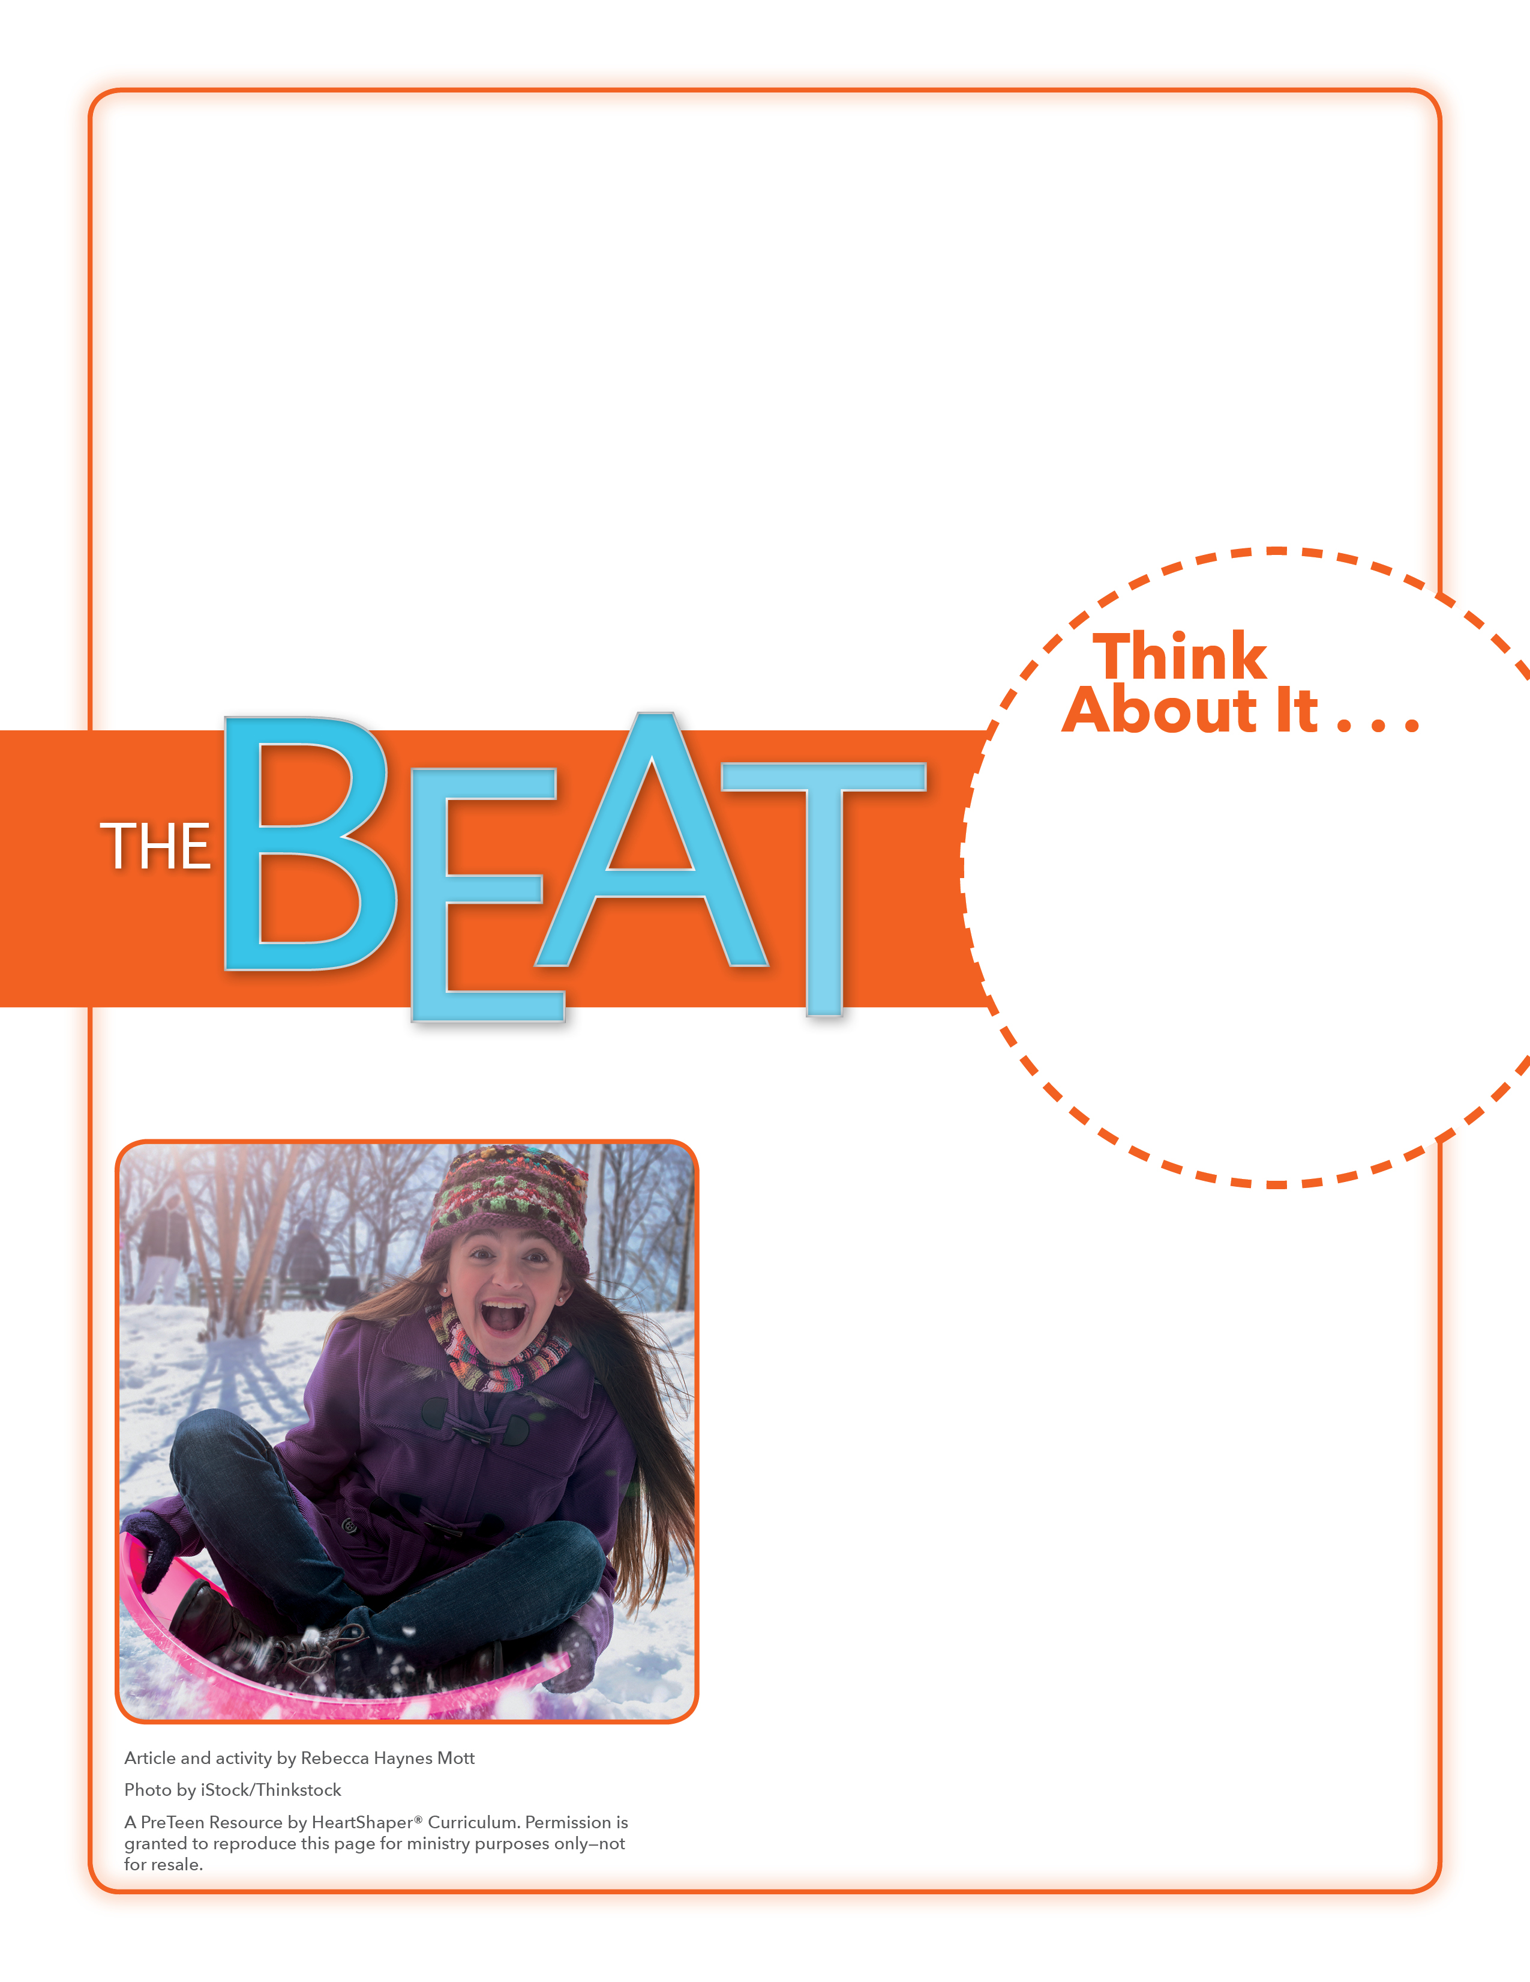
• Who needs to know about safety precautions for fighting the flu and keeping it from spreading?
• What advice would you give to someone who hasn’t had the flu yet?

Stop That Epidemic!
What will you do this week to share the gospel and show love to others?
Draw on the board a table with two columns. Title the first column “Flu.” Have kids answer these questions about the flu: Who might be most likely to get the flu? What could you do to help others avoid the flu? Write the kids’ answers in that column.
After a few minutes, label the second column “Sin.” Ask the same questions: Who might be most likely to sin? (Answer: everyone; see Romans 3:23) What could you do to help others avoid (or overcome) sin? Write the kids’ ideas on the board. Then SAY: Everyone needs to know about Jesus and God’s love for them. Let’s think about this as we dig into God’s Word.

February 4, 2018
Lesson 10
Do you know anyone who has the flu? Doctors say the number of people getting sick with the flu this season is the highest it has been in 10 years, and the numbers are still growing. The flu is widespread in every state except Hawaii. Before the flu season began, doctors suggested a number of precautions for avoiding the flu, such as get a flu shot, wear a mask, stay away from crowds, get extra rest. Many people ignored this advice because they didn’t realize how bad the flu would be this year. Because the flu is so contagious, some schools have had to close for a few days so that kids and teachers can get well. Doctors everywhere are urging people to follow the experts’ guidelines and work together to keep the flu from spreading further.

