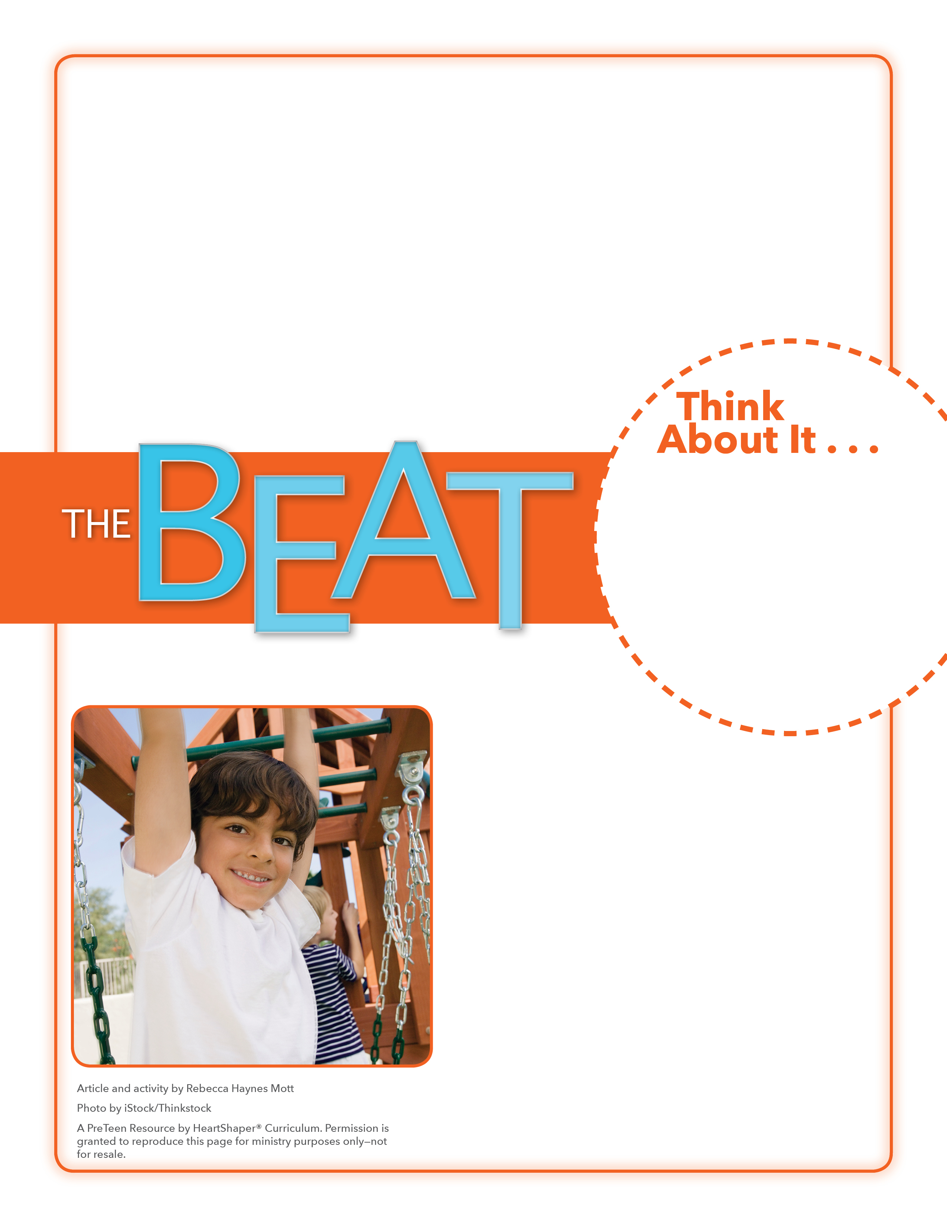
• When are some times that you feel sad? scared?
• What kinds of feelings, or emotions, do you have on a regular basis?

Short Stories
Will you thank God for meeting your emotional needs?
Ask students to think about the upcoming holiday season. Tell them to call out some emotions they and others might have during the holidays. (These might include: excited, worried, disappointed, frustrated, confused, sad, happy, grateful.) As they call out emotions, list them on the board. Ask for a volunteer to choose an emotion and then make up a short story that happens during the holidays and in which a person shows that emotion. After the volunteer shares the story, have another volunteer do the same. Keep going as time permits. SAY: Emotions are a part of life. Let’s dig into God’s Word and see what it says about a very hard situation some people faced and the emotions they must have felt.

November 20, 2016
Lesson 12
Sophie is a lonely 10-year-old orphan who has insomnia. One night, while everyone else is asleep, a giant hand reaches into a window at the orphanage and captures her. The hand belongs to a big friendly giant, who whisks her away to the land of the giants. In the book and movie The BFG, Sophie and the giant have many adventures—some are fun, while others are sad or scary. One review of the movie calls it a “roller coaster of emotions.” The BFG (Sophie’s name for the big friendly giant) doesn’t really fit in anywhere. Humans fear him and other giants bully him. But he and Sophie grow close as they work on important things, and in the process, the BFG and Sophie learn that they can share feelings and trust each other. When Sophie asks the giant why he chose her from the orphanage, he replied, “Because I hear your lonely heart.”

