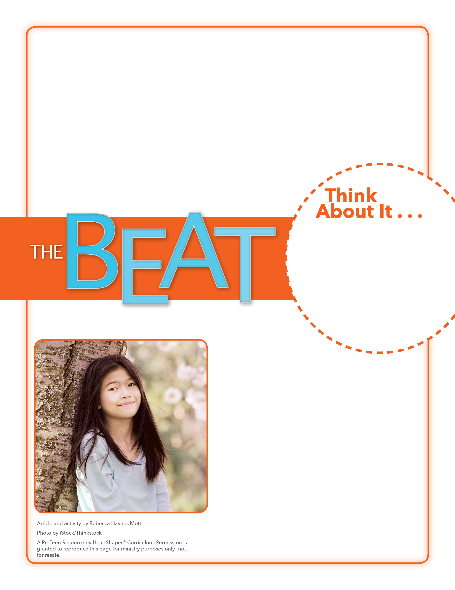
• How many different kinds of friends do you have?
• What makes someone a close friend or BFF?

What Kind of
Friend?
How will you be a friend God’s way?
Give each student an index card and a pencil. Ask preteens to write three names on the card: the name of a very close friend, the name of a good friend, and the name of a school friend or activity friend. When everyone is finished, ASK: What makes someone a good friend rather than a very close friend? What makes someone a school friend or activity friend rather than a good friend? Accept responses. SAY: Friendships are important, and God’s Word has a lot to say about friendships. Let’s dig into God’s Word to see what it says about how we each can be a friend God’s way.

August 14, 2016
Lesson 11
Pop singer Taylor Swift is famous for many things, including her millions of dedicated fans. She is also famous for her close-knit “squad” of friends. Taylor regularly invites her famous BFFs to sleepovers and cookouts and parties. Fans often wonder how Taylor manages so many relationships. Experts say having too many close friends could be very difficult. But Taylor disagrees, saying she picks friends who challenge and motivate her and make her want to be smarter, stronger, and better. In February, Taylor connected with a friend she has known most of her life. Taylor was maid of honor for the wedding of Britany Maack, a friend she has had since childhood. In the note asking Taylor to serve, Britany wrote, “You are more than a friend, you are more than a best friend—you are my sister.”

