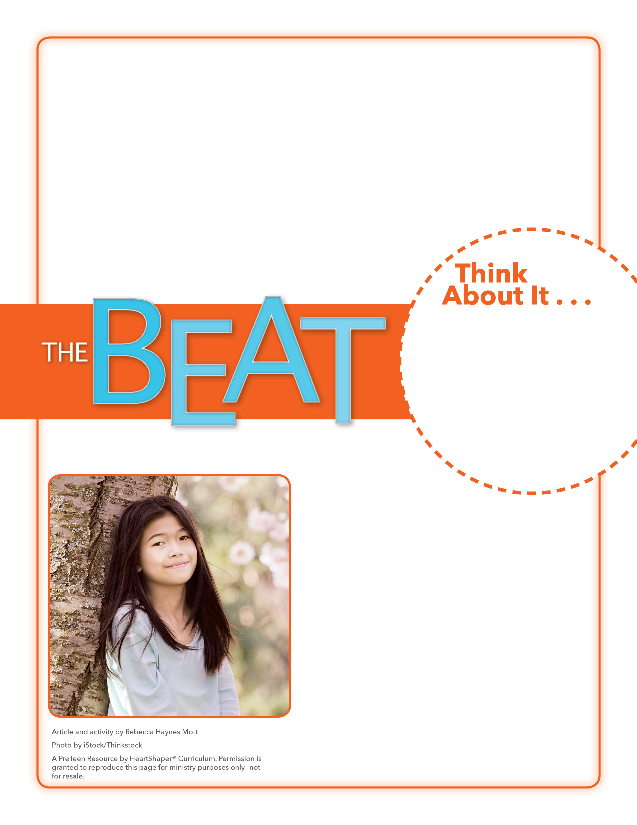
• What difficulties might people face if they have a physical disability or weakness?
• What difficulties might people face if they have a learning or emotional disability or weakness?

Brainstorming Time
Will you commit to letting God use you in spite of your weaknesses?
Many people have learning, physical, and emotional weaknesses and challenges. Set a timer for three minutes. Lead preteens in brainstorming a list of learning, physical, and emotional weaknesses. Write those on the board as students mention them. Then set the timer for another three minutes, and let preteens call out abilities that people with these challenges might have. SAY: Let’s dig into God’s Word to learn about a weakness the apostle Paul had. We’ll discover that God can use people with weaknesses.

August 7, 2016
Lesson 10
What were you doing on July 17? Millions of people around the world were celebrating the third annual Emoji Day. People celebrated by posting one of the more than 1,851 emojis to show their feelings. The little symbols have become so popular that last year, one emoji—a face crying tears of joy—was named the “word” of the year. This year, Emoji Day was extra special for the more than one billion people who live with disabilities. Until this year, there was only one emoji—a person in a wheelchair—to represent all disabilities. But on Emoji Day, 18 new emojis were released that include emojis representing people who have hearing impairments, individuals with prostheses, other disabilities, and even a guide dog.

