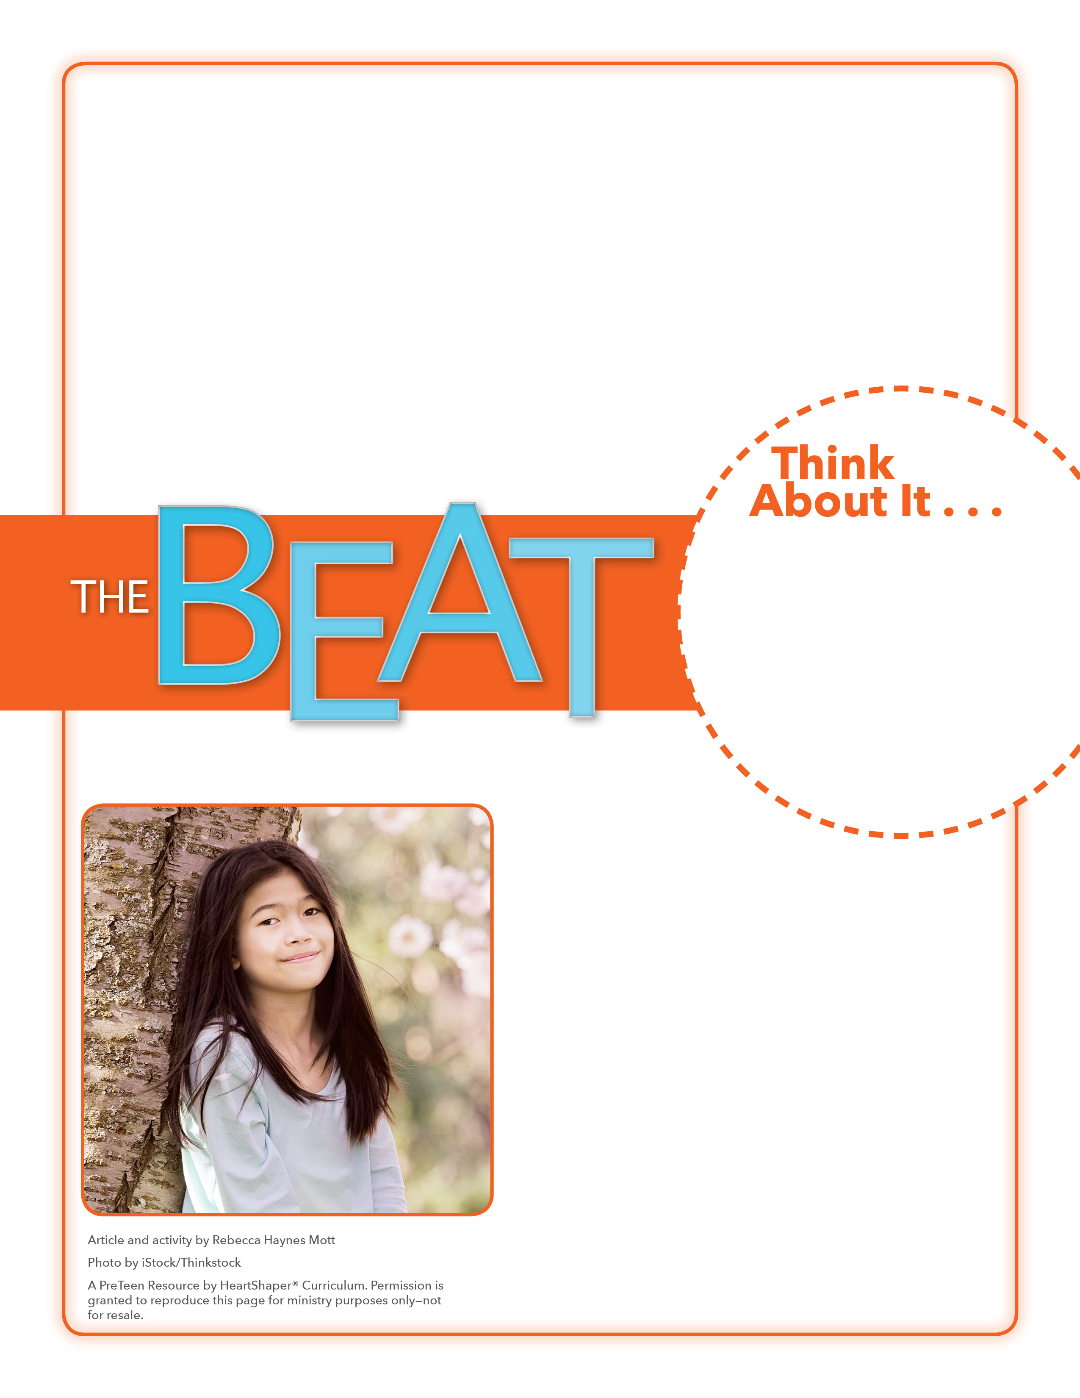
• What ability does Candace have?
• What talents and abilities do you have?

Comets and Stars
How will you use your talents and abilities for God?
Draw a long arc across the board. SAY: Some talents and abilities are like thrilling comets, streaking across the sky. Others are like stars, steady and bright. They aren’t as flashy, but they’re just as beautiful. Have preteens call out some talents and abilities. Write the ones that are more noticeable, like comets, on the arc. Write other, more behind-the-scenes talents and abilities on the board and draw a star around each of them. Whether or not you have talents and abilities that are noticed much by others, it’s true that God gives us different talents and abilities. Let’s dig into God’s Word to see what it says.

July 3, 3016
Lesson 5
When Candace Payne filmed herself laughing hysterically while trying on a mask of the Star Wars character Chewbacca, she had no clue that it would change her life. But overnight, that Facebook video went viral, and Candace became known as the “Chewbacca Mom.” Since the video was posted on May 19, it has had more than 141 million views. Candace has received gifts, made celebrity appearances, and has been made into a Hasbro action figure. She says that when she was 16 years old, she dreamed about her life being used for God’s glory, but she didn’t know how that might happen. Since her ability to bring joy to others has brought Candace fame, she’s using it to share her faith. She tells others about the true joy that comes from faith in God. At a youth conference just two days after her video was posted, Candace reminded kids attending the conference to always use the talents and abilities God has given them for His glory.

