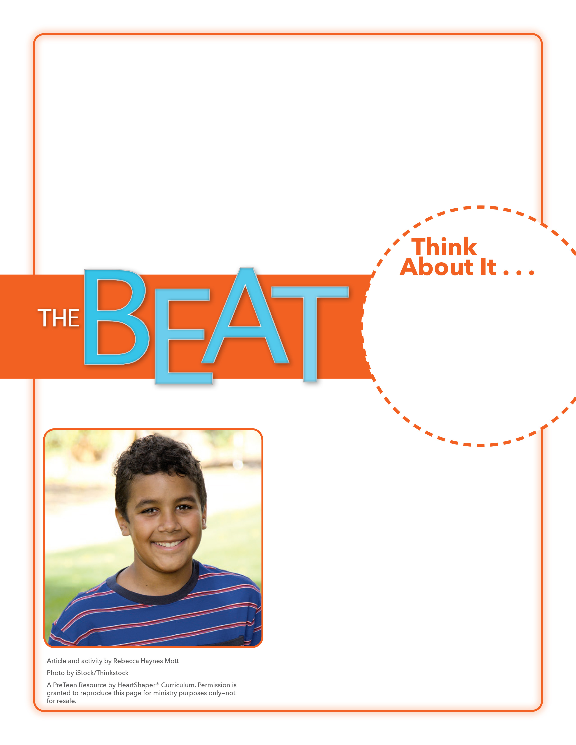
• What do you know about your family’s ancestors?
• Why do we need to know about our spiritual ancestors?

Our Spiritual
Ancestors
Are you willing to commit to growing in your knowledge of God’s Word and His plan?

On the board, draw a Venn diagram (two large circles that overlap). Label it: “Our Spiritual Ancestors.” Label the left circle “Hall of Fame,” the right circle “Hall of Shame,” and the intersecting circle “Both.” Read the first name from the first Bible time line—Noah. Ask a volunteer to go to the board and, based on what she knows about Noah, to write Noah’s name where she thinks it belongs, and why. Do the same with the rest of the names from the first Bible time line. SAY: What ties all the events and people together in these eras is their place in God’s plan. Remember, during these eras, God prepared for salvation.

March 13, 2016
Lesson 2
The TV show Finding Your Roots, is all about tracing your ancestors and learning about them. Last year it was revealed that one guest, Ben Affleck, was so embarrassed to discover his family had been slave owners, that he convinced the director to not air that part of the show. Viewers were angry when they found out, and the director and Affleck—who plays Batman in the new Batman v Superman movie—apologized for hiding the truth. (Display Resources sheets 1–4 in order. Draw students’ attention to the first Bible time line.) This time line represents the eras of the Creation & the Fall and the Patriarchs. (Have volunteers read the text under each icon.) These are major events that happened and important people who lived during this time period. You could call these people—such as Abraham, Isaac, and Jacob—our “spiritual ancestors.” The Bible doesn’t hide anything about our spiritual ancestors. It tells of times when they did great things for God, but it
also tells of times when they did wrong.

