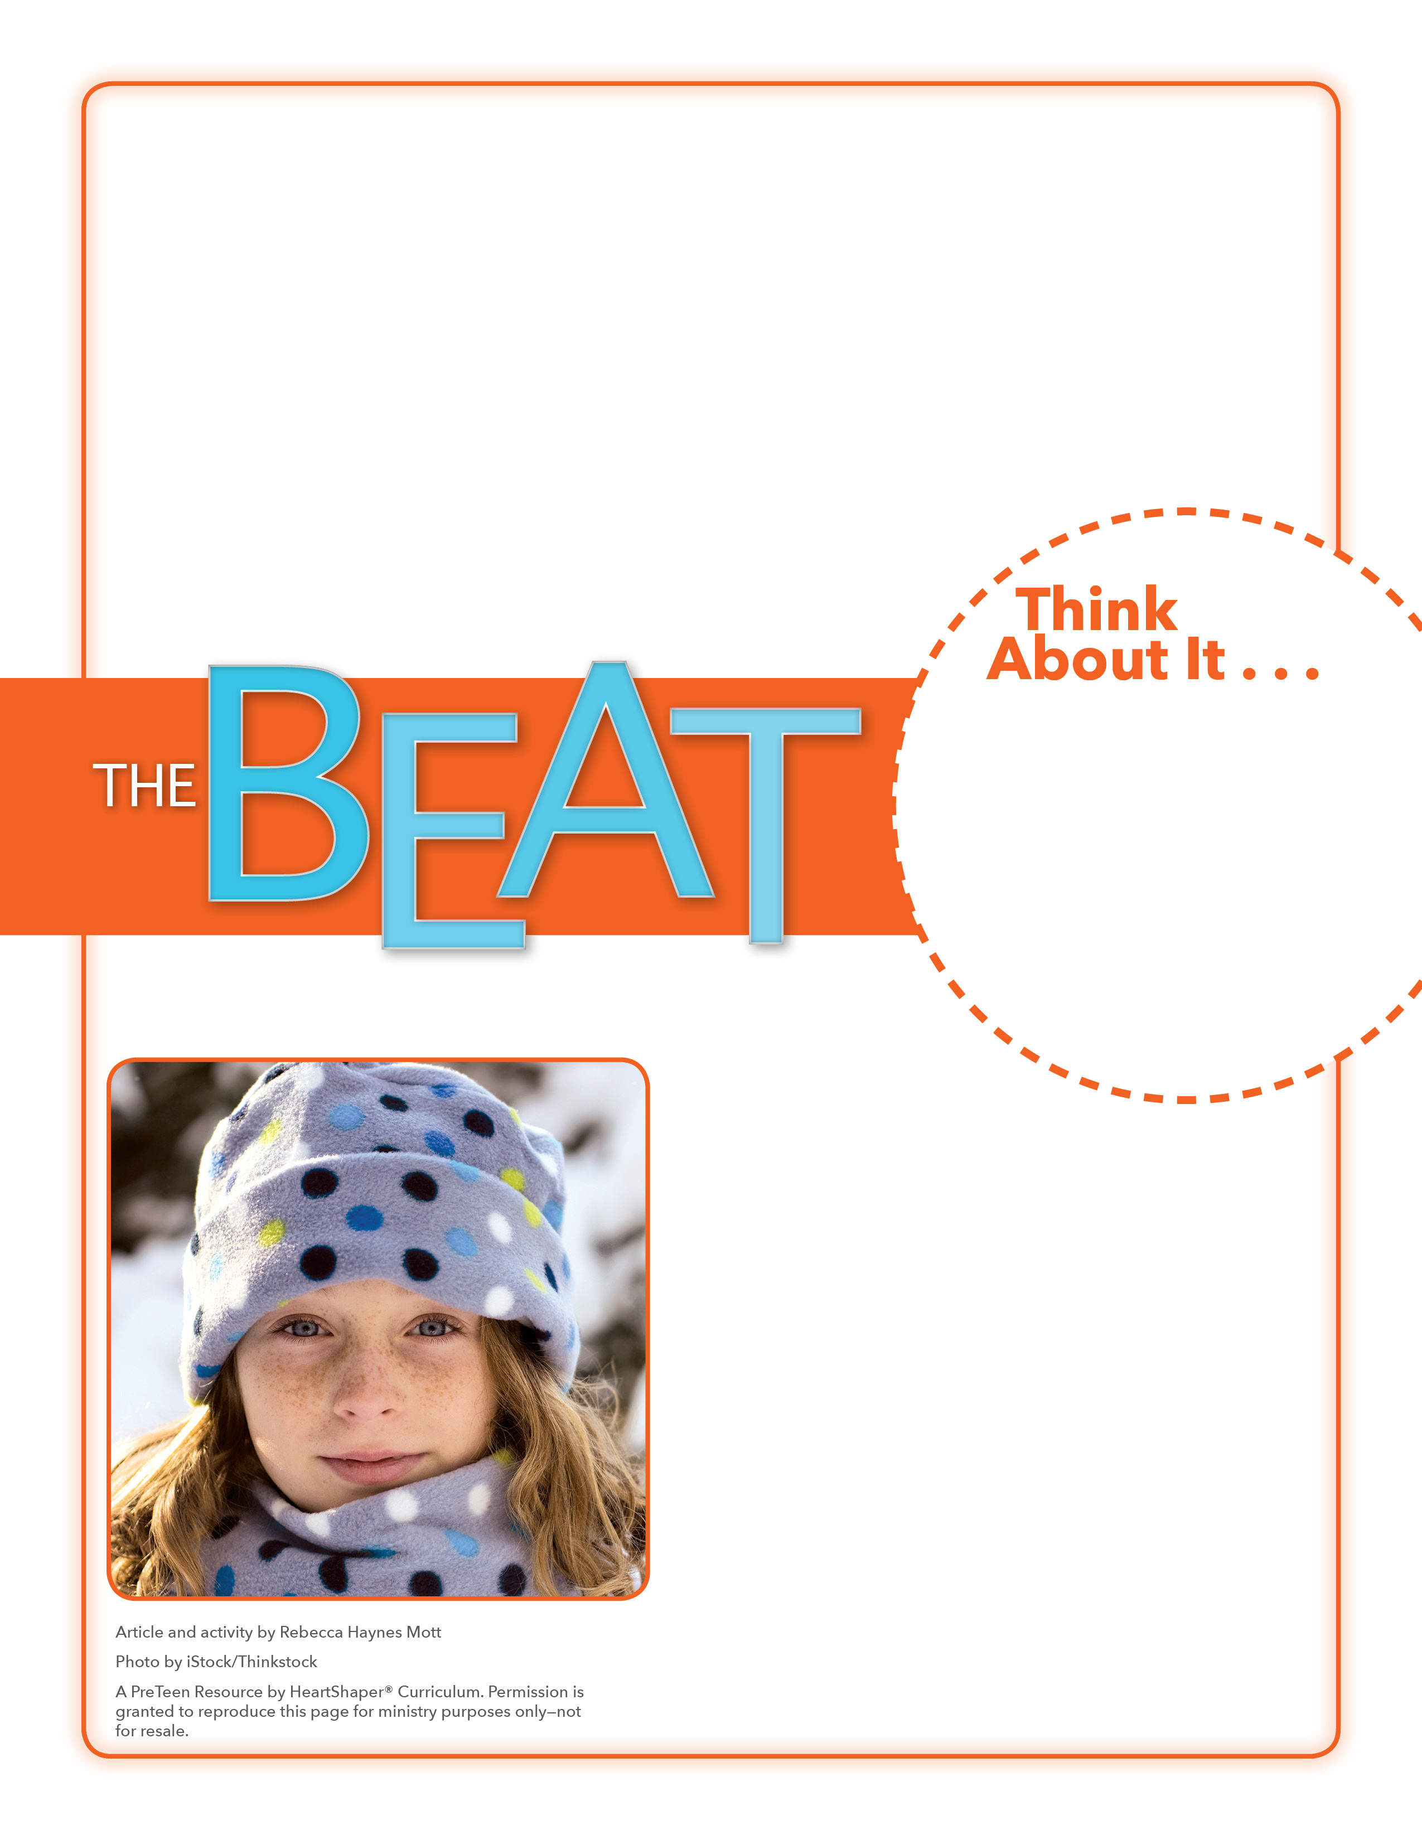
• Why do you think Maddie and Morgan wanted to help homeless people?
• Why do you think others wanted to help too?

Helping Lists
How will you show love by helping others?
Divide the class into pairs, and give each pair two sheets of paper, pencils, and colored pencils. Preteens should label one paper “Help for Others” and the other paper “Others Help Me.” Tell students to write on the “Help for Others” page ways that they’ve helped others. They should write on the “Others Help Me” page ways that others have helped them. If you have time, students could decorate their papers as though they were blankets. When everyone is finished, let students share their lists. SAY: Let’s dig into God’s Word and discover what Jesus taught about the importance of helping others.

February 14, 2016
Lesson 11
In 2014, on their way home from the Texas State Fair, Maddie and Morgan Manning saw something that would change their lives. The 13-year-old twins from Ada, Oklahoma, spotted homeless people by the side of the road. They decided they had to help. With assistance from family and friends, the girls worked for five months to crochet and knit hats and scarfs and to make no-sew fleece blankets. Before they knew it they had made hats, scarfs, and blankets for over 100 people. The girls organized the Bundle Up Club, a group that continues to make warm things for those in need. Maddie and Morgan also started Project Baby Bundle that makes baby hats and blankets for a local crisis pregnancy center. They say that their motto—“It’s a cold world outside, let’s blanket them in His love”—is inspired from God’s Word.

